TACTUAL PERCEPTION OF FLOORS
Marc Crunelle

Abstract - With the aid of ground floor readings of houses from three continents and with phenomenolo- gical observations, this text attempts to demonstrate how the kinesthetic sense of touch of our feet is each time similarly stimulated in the same way. A person entering a house progressively slackens, and the attention that he is obliged to give to his movements diminishes step by step and is transferred to other activities. Touch is a sense of closeness, of contact and the fitting of the floors in houses favours this contact; and therefore the encounter with the other.

READINGS OF THE FLOOR PLANS OF THREE HOUSES.

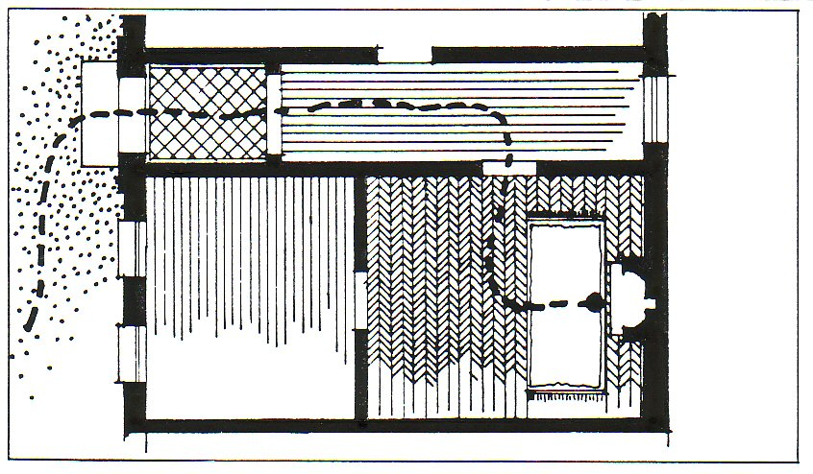
Il. 1 : nature of flooring encountered in the path of house in Brussels
BRUSSELS:
outside, gravel that grates and on which our feet attempt to find a certain balance, then a stable threshold of stone slightly hollowed at its center; then, in the entrance, large squares of flat stones with strong and wide joints; in the corridor, wood floors with tight joints; in the living room, parquetry and finally in the front of the fireplace, a large thick and velvety carpet.

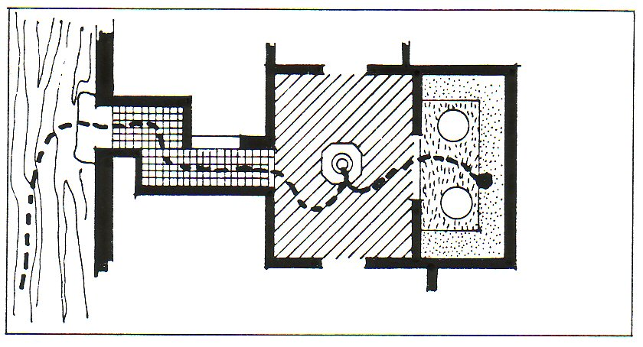
Il. 2: nature of the flooring encountered in the path of house in Morroco.
MORROCO:
A dirt road: hard in summer and muddy in winter; a closed threshold made of stone; ceramic tiling in the hall;

Varnished brick in the patio (Woust ed dar) and marble around the fountain and finally a rug in the living room (Diwan).

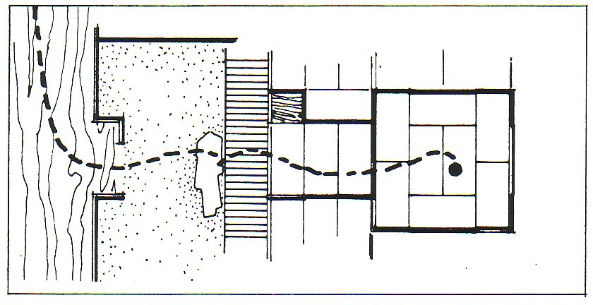
Il. 3: nature of the flooring encountered in the path of house in Japan.
JAPAN:
a dirt road: furrows or mud according to the season; past the entrance door, an earthen space (Doma); facing the entrance, one removes one’s shoes to accede to a slightly elevated area made of wooden planking (Ita No Ma) having a smoother and flatter surface; in the antechamber, mats made of rice fiber (Tatamis) and in the “center” of the place, cushions on the matting.

Three paths are obviously insufficient to establish a general rule on fittings of grounds. However:
• All Middle Class houses of the XIXe Century and a great number of actual houses in Europe, reproduce, in the same sequence, this chronological aspect of materials perceived by the feet, as described in the example of the Brussels house.
• The plan of the Moroccan house is traditional, and may be applied to most North African houses.
• For Japan, J. Pezeu-Masabuau has shown that, if the proportion of areas, one in regard to the other (mud, wood, tatamis) varied from North to South of the country, the chronological sequences of these areas has always been respected and that “the coexistence between these grounds and their respective similar gradual processes, identify the Japanese country and urban house, old and recent”.

However, we may notice that:
• in each of the three paths explained above, the more we reach the heart of the house, the “center” of the place, the softer the materials become. It appears that, each time, a similar tactile practice is established, willing to create in the center of the houses, the maximal softness of the grounds, optimal expression in opposition to the outside world: jolted, disordered.
• This gradual process of materials covering the grounds and perceived by feet, is similar to the path going from outside to inside, from cold to warm, from disorder to order, from rough to manufactured. Sounds follow the same process: they are “high pitched” outside, on hard surfaces, and they become “thick” and “subdued” on smooth surfaces.

Maybe we can also find what we could call “the securing function of the grounds” which consists in the behavioring of the body into a situation where tactility and movements are as fluid as possible, less present in mind; in other words, that we do not pay anymore attention to them. As though, in the restricted energetical budget that each man possesses, his attention is drawn from his kinesthetic sense, becoming weaker in favour of other less primary interests: dialogue, human contacts, relaxing, leisure.

On outside grounds, tactility is very present and requires a lot of energy. The degree of energy needed to walk without hitting things, without stumbling, and “looking forward”, means that we are not in good condition for relaxing, or having a philosophic conversation or romantic behaviour. We are constantly obliged to watch our step. On the contrary, in buildings, the internal set-up favours our body to have other behaviours. The touch, so present outside, this kind of touch that we can call primary, even of survival, gives place to an other form of tactile sensibility, more sensual: our awareness of the materials around us (softness of fabrics, thickness of carpets, velvetyness of cushions) and of a non aggressive environment which favours the body, through the awakening of new tactile registers, to a behaviour open to dialogue and contacts. What the English call the “home”, this warm and felty place, is the typical example.

ANALYSIS OF THE DIFFERENT PATHS

1. We may observe on those different paths, that after the gravel, a threshold of plain stone at the entrance of the door, or, like in Japan, a wooden area slightly elevated above the ground, becomes a tactile welcoming and secure mark, due to its stability. This is in fact the first step to invite people to feel at ease. During centuries, dirt roads were quite difficult for walking: muddy and slippery during rainy seasons, tough and full of rut during dry periods. Walking required a lot of attention to avoid stumbling. The flat and stable threshold was then the first tactual and tangible sign of the passage from a chaotic to an orderly world.

2. Coming after, under the feet, paved stones, tilings, marble, planking: a succession of materials becoming more and more glossy, more and more smooth, of a gradual hardness and assembled with wide joints at the start to switching to tight joints later.
This is the second phase: man finds his security by stages. After the threshold, we make his gestures more fluid, less contracted, by using flatter surfaces, smooth and without accidents, hindrances (reason why people are reticent to have a slab of wood on the floor); steps of staircase of equal height, door handles at the belt level, easily accessible electric switches,... all things created to facilitate our movements and where only touch by feet (of small surfaces) and occasional touching of hands is concerned. Kinesesis generates in the first place this comfortable feeling: walking on flat grounds requires less attention than walking on uneven grounds. This produces a feeling of distress, confidence, gives him a serenity because man knows that he will not be surprised by a surface accident.

The previsibility of our movements is linked to the same mental procedure: if we know that the ground will be flat, we will feel secure. If we know that the steps of a staircase will have equal heights, we can climb it with our eyes closed. It is only at the last step that we are surprised: we raise the leg too high and fall a little.

In brief: lack of foresight in our movements = insecurity
Forecast of our movements = frees the attention, gives confidence.

This succession of materials going from hard outside to smooth at the “centre” of the place, which step by step slackens man and makes him feel confident and trustful, appears to be always the same. Any contrary way in this progression to the leveling of the relieves would shock us. Indeed, we never saw a wooden floor in an entrance hall followed by a living room of paved stones; nor a corridor with plain carpeting giving access to rooms of mud or gravel floors.
All things have shown that this “good practice” or the obvious logic of the secure grounds covering is universal. Furthermore, while waking, any accident in the relief of the ground, any sudden blow (to stumble on a strip of parquetry, or on an unsealed tiling,) is badly perceived. Man thus contracts himself: the forecast of his movements is suddenly stopped, adrenalin circulates in his blood, and maybe he swears.

There are some places where these accidents of paths “waking up” man were built intentionally, for example, the courtyards of Trinity College in Cambridge. There, each huge central lawn is bordered by a surface of stones. In order to avoid walking on the grass, the path is protected from the lawn by a strip of large pebbles measuring approximately 30 cm. This strip has the advantage of informing anybody who touches it, that he is leaving the walking area because the relief is different and the walking becomes instable. This solution is particularly welcoming during the night or in the darkness: the reflex of coming back to the flatter path is unconscious and automatic. It would not be surprising that even a drunk would react the same way.

Another example: in the corridor of Orlando Airport (Florida), floors are covered by glossy, plain linoleum. On each side, along the walls and for about 50 cm, this linoleum is marked with embossed lozenges. The feet automatically follow the glossy area. If we approach the walls, this slight relief has the effect of putting us back on the smooth surface (which is not necessarily the shortest one), but it’s easier to walk. Even, the roller suitcases that we pull easily begin to tremble, and make noise when leaving the smooth area before knocking the walls.

Planeness of the ground surfaces means safe areas and is perceived as such. A shop, a hotel or any place which does not contain this factor generates mistrust and does not attract us (for example: broken tilings, torn carpets ...).Stable, shiny floors, but not too slippery, because this produces the opposite result, and thus not the wished for security.
Blaise Cendras liked to explain in which conditions he interviewed Mussolini. He had the habit of meeting the reporters coming to speak with him, perched on a high estrade, located at the end of a huge meeting room and where the parquetry was “the best polished in all of Rome”. Anybody who entered, a little impressed, would not walk five steps without falling on the ground. Mise en scène serves to disarm the most voluntary reporters. Cendras, advised of that fact, had trained himself the preceding days in different places where parquetry was particularly slippery and realized that it was only with a cadenced walk and with a very determined manner that he would stay in equilibrium.
That’s what he did a few days later, arrived with a cadenced step while muttering a military song to the foot of the Estrada , climbed on a chair and found himself face to face with Mussolini.

3. Let’s come back to three networks explained above. We notice also that after the stone, the tiling, the wood, appear at the “center” of the places, thick carpets, cozy materials, and upholstered furniture. In Morocco, benches and round sofas; in Japan, tatamis of rice fibers. Man secured in his movements, due to the previous floors fittings, relaxes himself more completely while trampling a plush carpet. If he is invited to enter in contact more largely with materials, not only with his feet and his hands, also his back, his legs, his buttocks, he looses his “shield”, grants his trust, settles himself down in a sofa, among the deep and soft cushions, blots himself in an armchair. He liberates all the attention that he gives to his movements and his gestures thus allowing himself to give his attention to other people, to communicate.
In our daily behaviour, when we invite someone to sit down, we slide a pillow on the seat of his chair, we fuss the cushion, etc...we want the other be at his best, by means of perceived tactile data. This explains also why Alvar Aalto never uses metal in his furniture creations, because he said “this material should never be in contact with the skin”.
This is the third stage: the person is secured and reassured because of what he has previously touched, comes into greater contact with materials and allows himself to be carried away by the setting. In the same way as he has granted his trust, he establishes a closer contact with the other person and relates to him in a more relaxed manner. Communication is therefore made easier.

4. If one wants to make the other person feel secure by creating a safe surrounding where materials are the softest, the finest and the most pleasing to touch, so as to be in the most complete contact, it is the bedroom that should be the most sensually tactile. It is there, where the encounter is the most intimate, where touch is the most sensual, where the other person is the closest, where the largest cutaneous surface is in contact with different fabrics, where the textures are the softest: from sheets to the ultra light comforters (duvets), to the bed where just like the ads say “you feel as light as air”, etc... This would account for a remark made by someone telling me of an unwelcoming brothel: “even the sheets were starched” !

This idea of softness is confirmed by answers given to a survey of people buying carpets, carried out by the Belgian company Cego Makrotest. They maintained that the texture and the pile of the carpet were not important considerations. Nonetheless, in thirty-six percent of the cases, the purchase was made for a bedroom. Furthermore, according to Jésabelle Ekambi-Schmidt, in France, the carpeting of the master-bedroom is thicker than the one in the living-room. This carpet, on which people walk barefooted, is the third most important item, after the bed and the wardrobe.

5. The different observations described here-above allow us to infer that a lack of differentiation between the inside and the outside - a lack of softness, are synonymous to poverty. Shantytowns, or the old farms such as those found in Brittany as described by Pierre Jakez Hélias, are typical examples of this: dirt floors inside - dirt roads outside. Similarly, the floors of churches that are made of the same material as the streets outside (usually stone) from this point of view, is seen as a sign of humility.

On the other hand, first class hotels, contrarily to these examples, signal their wealth and show the comfort that is intrinsic to the premises by placing thick rugs at the entrance door. The purpose of this is to reassure the guests by displaying the softest of textures upon entering, as a sign of greeting. This sensation of opulence, which comes from the rugs, spreads throughout the hotel: in the lobby, to the staircase, the elevators, and the corridors.

To walk on a soft surface while outside, is the highest sign of esteem and hospitality that can be shown to one’s guests, customers or important people. To “unroll the red carpet” to the foot of the plane or train for a foreign head of state; to have him walk down the stairs of the town hall for an important wedding, or as in the case of a decorator who had carpeting outside his shop, as a tactile sign of wealth. In these various examples, no gradation is sought or used. One goes from the sidewalk, which is hard, to a softer surface - from the brutal concrete to the smoothness of carpeting, from the hardness of stone to the softness of wool.

6. The different sequences for flooring do not always follow the patterns described here-above. If rugs and wall to wall carpeting are very popular (seven hundred million square meters are manufactured in Europe yearly), certain misgivings do exist about their presence in our interiors. If the custom of laying a rug on the floor has always been a sign of welcome since the Egyptians and the Babylonians, it’s meaning is not accepted as such by everyone. To some people a sense of security in a home is associated to the cleanness and finish of the floor. The cleaner it is, the more lived in it is, and the safer it is. To a lot of people, only things that can be cleaned with water could possibly be considered clean, and of course, this isn’t possible with rugs.

In the framework of my doctorate, experiments of semantic differentiation, performed using Osgood’s method, have shown that young people in their early twenties (average age of twenty-two), that to them carpeting seems dirty rather than clean. A lot of architects and doctors are reticent to the idea of having carpeting in hospitals. Their reticence is due to maintenance problems (soiling, dustiness, etc...): these negative aspects were also mentioned by consumers in the Makro test survey.

7. These last two decades have profoundly transformed our interiors. Innovative techniques have allowed us to reduce the differentiation which previously existed between the outside and the heart of our homes; therefore allowing us greater sense of security. In fact, we are witnessing a change in the gradation process of materials (stone) are now outdoors - on sidewalks - and paved streets have replaced dirt roads. Indoors, carpeting has replaced stone, marble, and tile floors.
These points attempt to illustrate the tactile role of floo-ring, which is to allow a gradual secureness through the necessary pedal perception and of kinesthesis (which is far less conscious than our sense of touch perceived by our hands). By means of these three floors plans from three continents, and a phenomenological lecture, I have attempted to demonstrate that the gradation of floor materials, from hard to soft, aims to relax people by thresholds; otherwise this range in textures, from hard to soft, from the street to the “center” of our homes would be senseless. In fact, functionally one material that would be hard and washable (i.e. vinyl), and would cover all floors evenly, in theory should be enough to keep us from the cold and damp. However, mankind has not changed it’s habits nor floor coverings, that are both soft and resistant (i.e. carpeting), adapting themselves to a psychological need that has always existed.

Touch is the sense of nearness, of contact and of encounters. A person will feel secure in a new surrounding if firstly, he is allowed freedom of movement, by means of smooth level floors; later, coming into contact with soft textures, he will allow himself to relax, and be more trusting, more in touch with the furnishings, and ultimately with the other person. Freed from the constraint of having to mind his movements, he understands that the soft materials that he encounters are signs of trust that are given to him because, the more I touch, the more secure I am . Similarly, the more secure I am, the more important the contact will be, therefore I know that I feel good here. This sense of feeling is the real proof of our acceptance of a place. If these conditions have been fulfilled, a person will feel good with himself and others, relationships are better, and communication is easier.

REFERENCES
Aalto, Alvar (1935), Rationalismen och människan, in: Alvar Aalto furniture,Helsinki, 1984, Ed. Museum of Finnish Architecture, 115-117.
Bettelheim, Bruno, Un lieu où renaître, Paris, 1979, Ed. Robert Laffont, coll.“réponses”, Livre de Poche Pluriel n°8354 J, 178-179. (Engl. A home for the heart )
Cegos Makrotest N.V. Brussels: survey made for the International Wool Secretariat, Brussels December 1981, non published.
Crunelle Marc, Exploration de la fonction tactile en architecture, Thèse de doctorat, U.E.R. Sciences du comportement et de l’environnement, Université Louis Pasteur 1, Strasbourg, 1987, 161-182.
Ekambi-Schmidt, Jésabelle, La perception de l’habitat, Encyclop. Univ., Paris, Ed. Universitaires, 1972.
Jakez-Hélias, Pierre, Le cheval d’Orgueil, Paris, Ed. Plon, coll. “Terres humaines”, 1975.
Pezeu-Masabuau, Jacques, La maison japonaise, Bibliothèque Japonaise, Ed. Publications orientales de France, 1981, p. 43.
Patrick Verschure, La Minka, introduction à 3 espaces, in: Architecture d’Aujourd’hui, n° 163, Paris, 1972, pp. 7-13.

